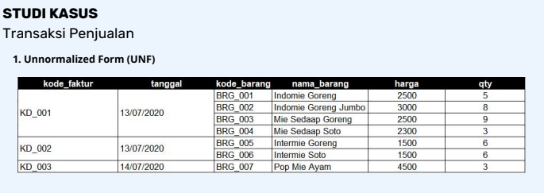

1. **First Normal Form (1NF)**

|  |  |  |  |  |  |
| --- | --- | --- | --- | --- | --- |
| Kode_faktur | Tanggal | Kode_barang | Nama_barang | Harga | Qty |
| KD_001 | 13/07/2020 | BRG_001 | Indomie Goreng | 2500 | 5 |
| KD_001 | 13/07/2020 | BRG_002 | Indomie Goreng Jumbo | 3000 | 8 |
| KD_001 | 13/07/2020 | BRG_003 | Mie Sedaap Goreng | 2500 | 9 |
| KD_001 | 13/07/2020 | BRG_004 | Mie Sedaap Soto | 2300 | 3 |
| KD_002 | 13/07/2020 | BRG_005 | Intermie Goreng | 1500 | 6 |
| KD_002 | 13/07/2020 | BRG_006 | Intermie Soto | 1500 | 6 |
| KD_003 | 14/07/2020 | BRG_007 | Pop Mie Ayam | 4500 | 3 |

1. **Second Normal Form (2NF)**

**T**abel faktur

|  |  |  |  |
| --- | --- | --- | --- |
| Kode_faktur | Tanggal | Kode_barang | Qty |
| KD_001 | 13/07/2020 | BRG_001 | 5 |
| KD_001 | 13/07/2020 | BRG_002 | 8 |
| KD_001 | 13/07/2020 | BRG_003 | 9 |
| KD_001 | 13/07/2020 | BRG_004 | 3 |
| KD_002 | 13/07/2020 | BRG_005 | 6 |
| KD_002 | 13/07/2020 | BRG_006 | 6 |
| KD_003 | 14/07/2020 | BRG_007 | 3 |

Tabel Barang

|  |  |  |
| --- | --- | --- |
| Kode_barang | Nama_barang | Harga |
| BRG_001 | Indomie Goreng | 2500 |
| BRG_002 | Indomie Goreng Jumbo | 3000 |
| BRG_003 | Mie Sedaap Goreng | 2500 |
| BRG_004 | Mie Sedaap Soto | 2300 |
| BRG_005 | Intermie Goreng | 1500 |
| BRG_006 | Intermie Soto | 1500 |
| BRG_007 | Pop Mie Ayam | 4500 |

1. **Third Normal Form (2NF)**

**T**abel faktur

|  |  |
| --- | --- |
| Kode_faktur | Tanggal |
| KD_001 | 13/07/2020 |
| KD_001 | 13/07/2020 |
| KD_001 | 13/07/2020 |
| KD_001 | 13/07/2020 |
| KD_002 | 13/07/2020 |
| KD_002 | 13/07/2020 |
| KD_003 | 14/07/2020 |

Tabel Barang

|  |  |  |
| --- | --- | --- |
| Kode_barang | Nama_barang | Harga |
| BRG_001 | Indomie Goreng | 2500 |
| BRG_002 | Indomie Goreng Jumbo | 3000 |
| BRG_003 | Mie Sedaap Goreng | 2500 |
| BRG_004 | Mie Sedaap Soto | 2300 |
| BRG_005 | Intermie Goreng | 1500 |
| BRG_006 | Intermie Soto | 1500 |
| BRG_007 | Pop Mie Ayam | 4500 |

Tabel Detail Faktur Transaksi

|  |  |  |
| --- | --- | --- |
| Kode_faktur | Kode_barang | Qty |
| KD_001 | BRG_001 | 5 |
| KD_001 | BRG_002 | 8 |
| KD_001 | BRG_003 | 9 |
| KD_001 | BRG_004 | 3 |
| KD_002 | BRG_005 | 6 |
| KD_002 | BRG_006 | 6 |
| KD_003 | BRG_007 | 3 |

DESIGN DATABASE

1

1

1

*

**Tbl_barang**

Kode faktur (Varchar(20) Primary Key);

Nama barang (Varchar(50)

Harga (int);

**Tbl_faktur**

Kode faktur (Varchar(20) Primary Key);

Tanggal Date

**Tbl_Detail Transaksi**

Kode faktur (Varchar(20) Foreign Key);

Kode barang (Varchar(20) Foreign Key);

Qty int;